New self balancing scooter io hawk two wheels self balancing scooter hoverboard hover board 2 wheels

Product Size:584*186*178
Color:Black, White,Pink, Gold, Blue, Green Red
Weight:10KG
Maximum loading :120kg
Max Speed:10KM\H
Motor power:500W(250W*2)
Charging time:1-2H
Range per charge:20-25KM
Range per charge:158W/4.4AH
The tire size: 6.5 inch
Charging Voltage - AC110-220V 50-60Hz
Packaging:67.4*28*24.5CM,1PCS/CTN, N.W:13.5KG
With Remote controller

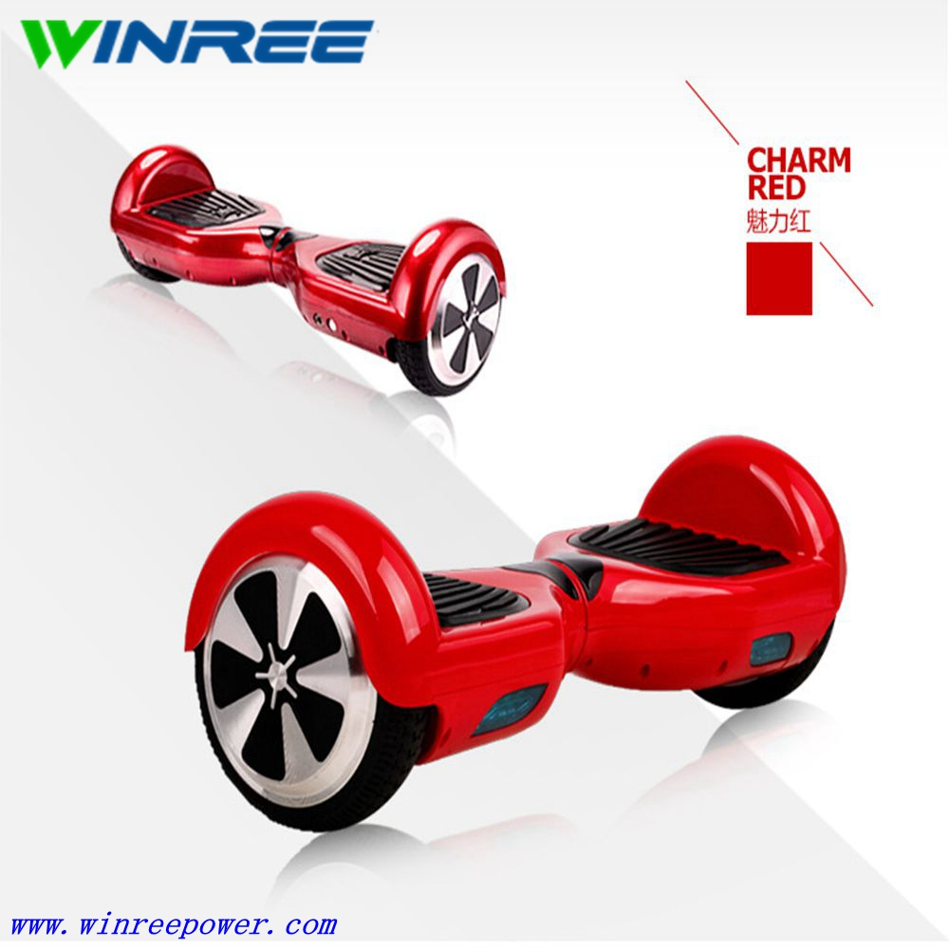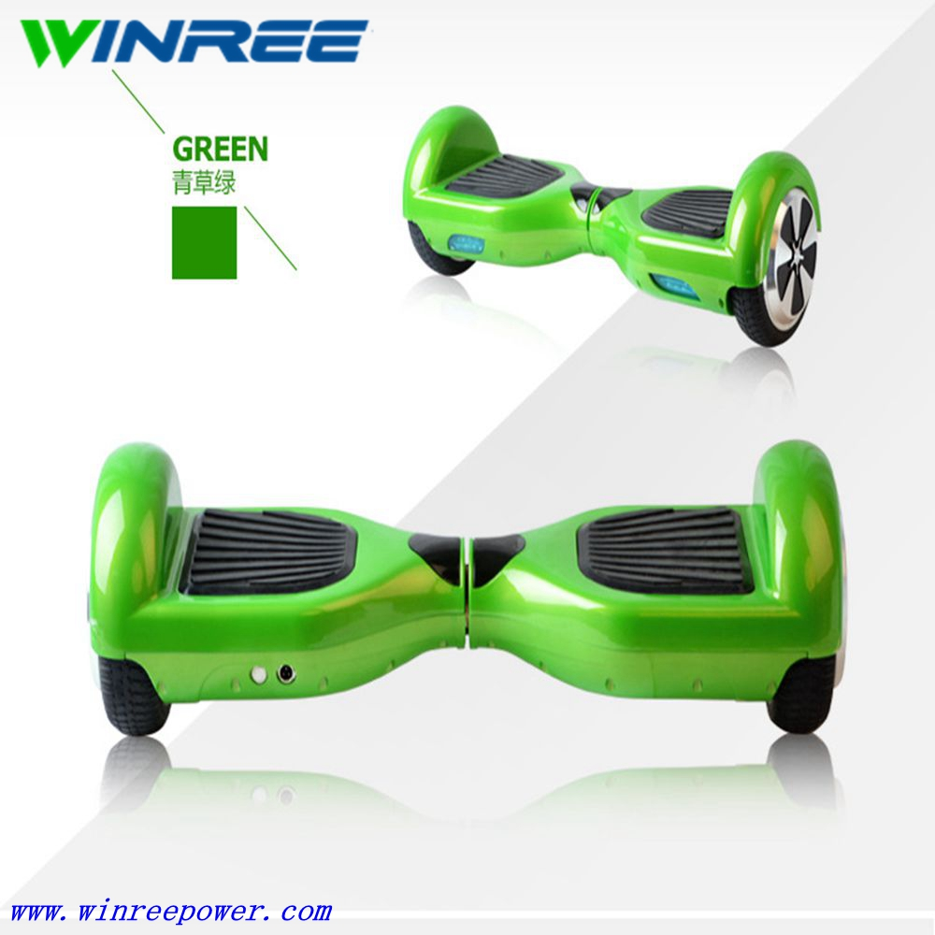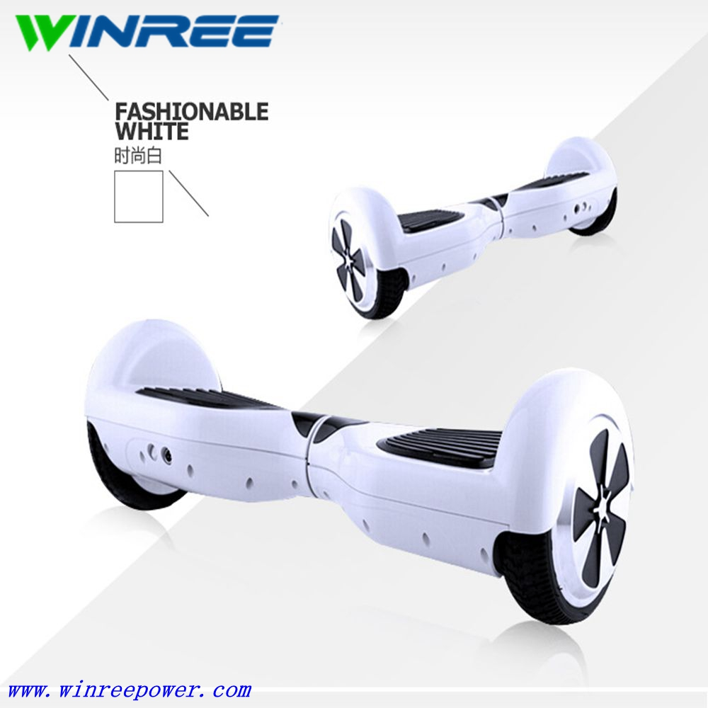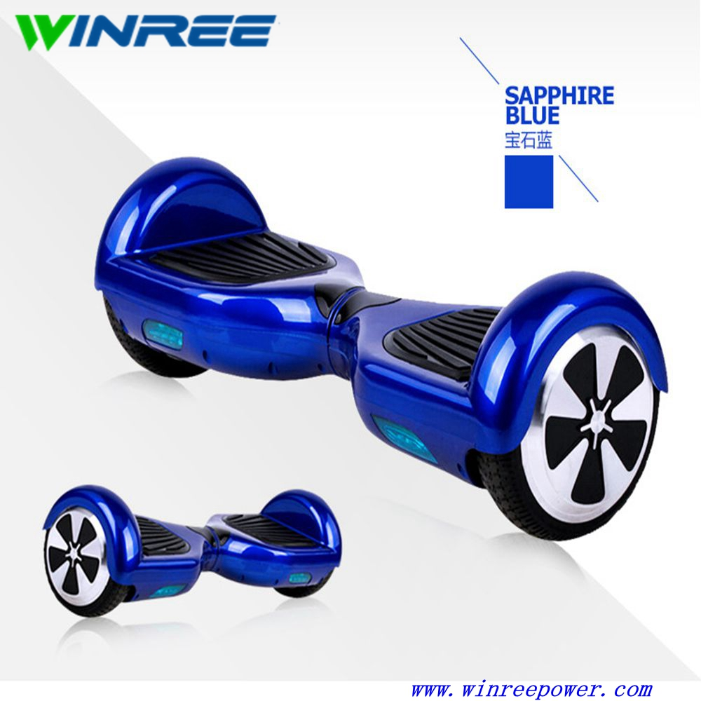
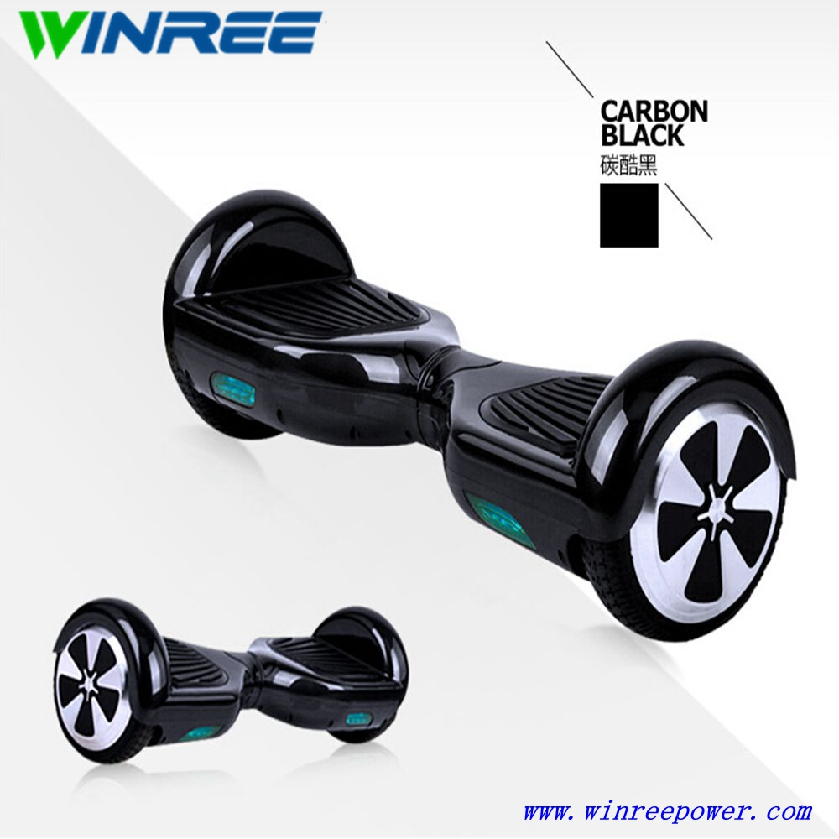

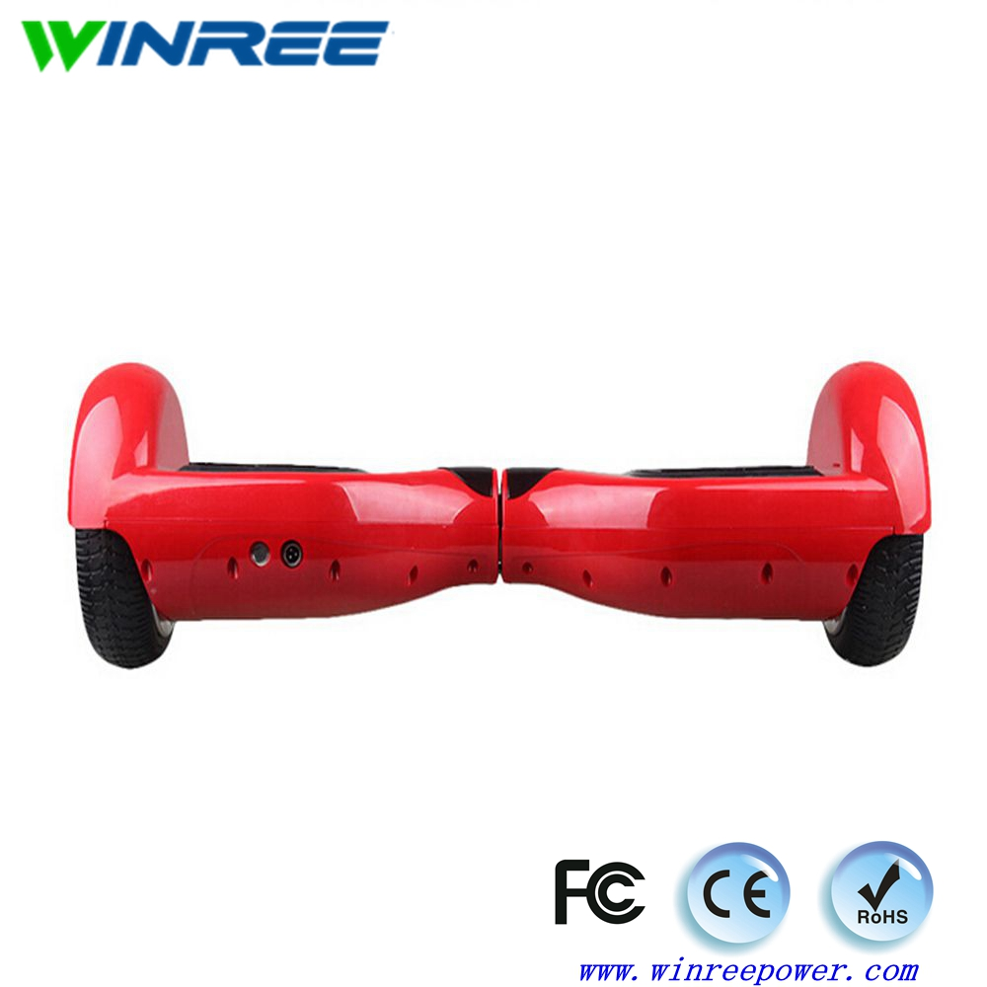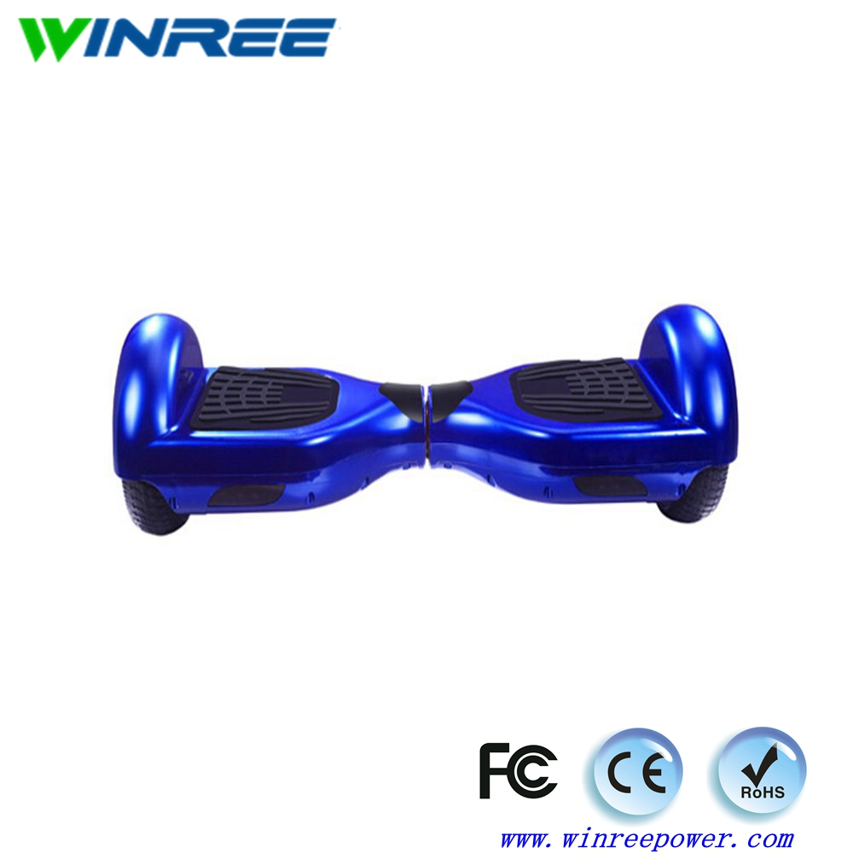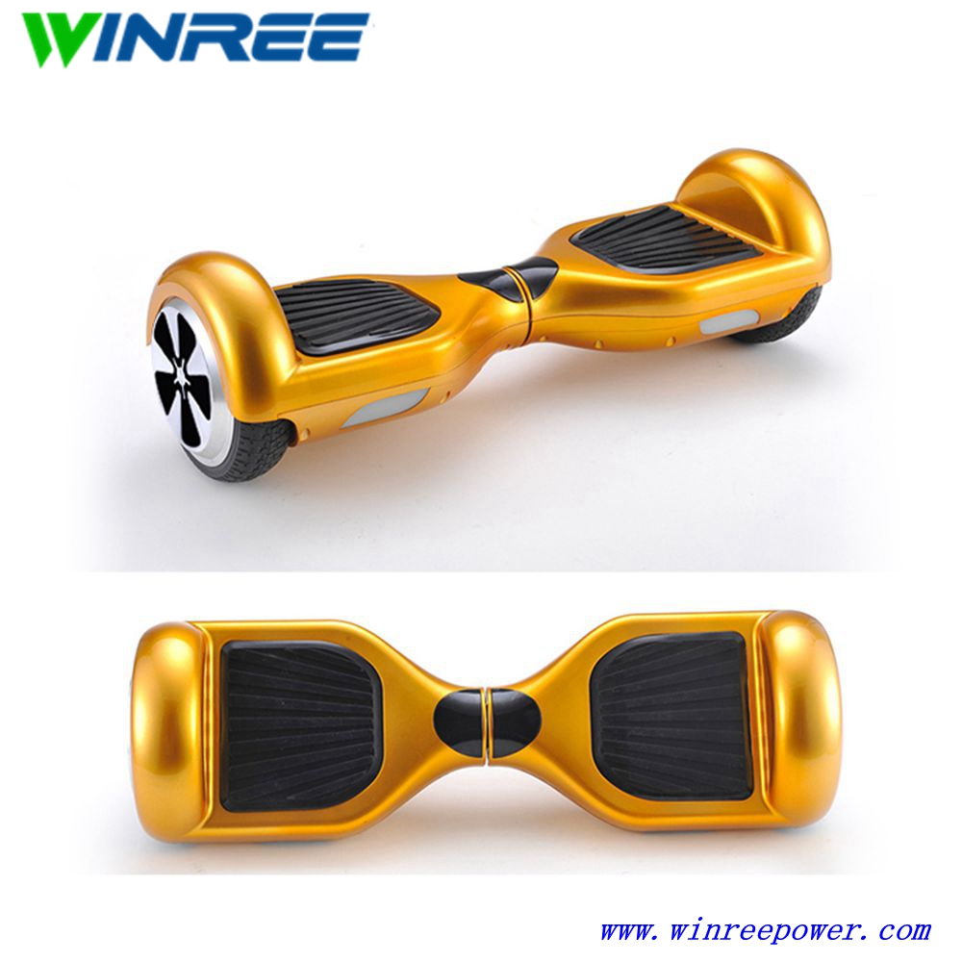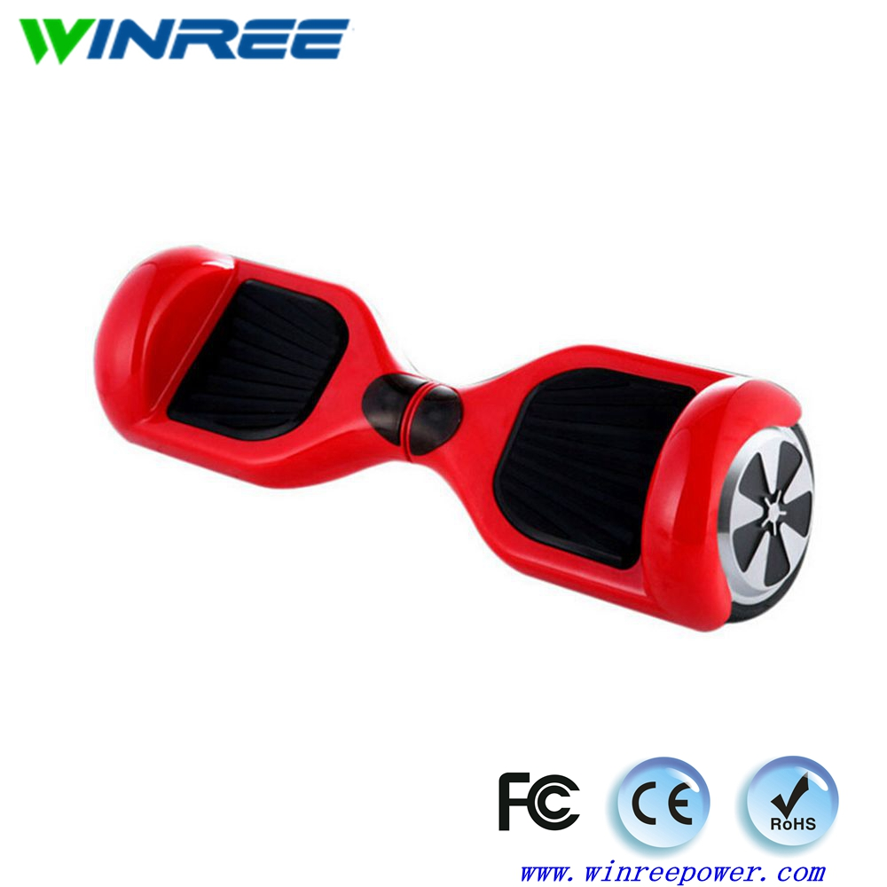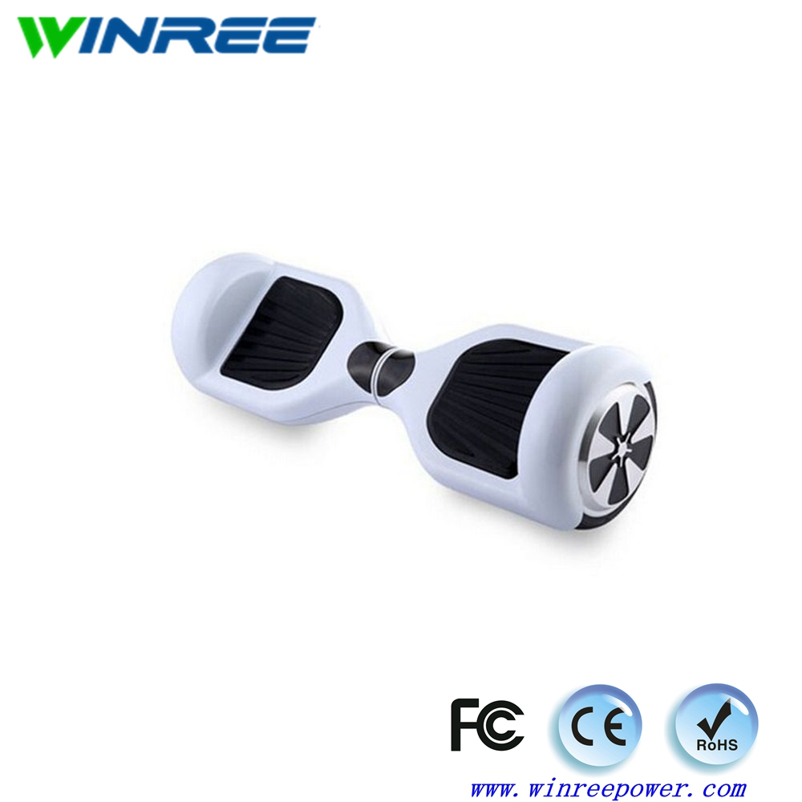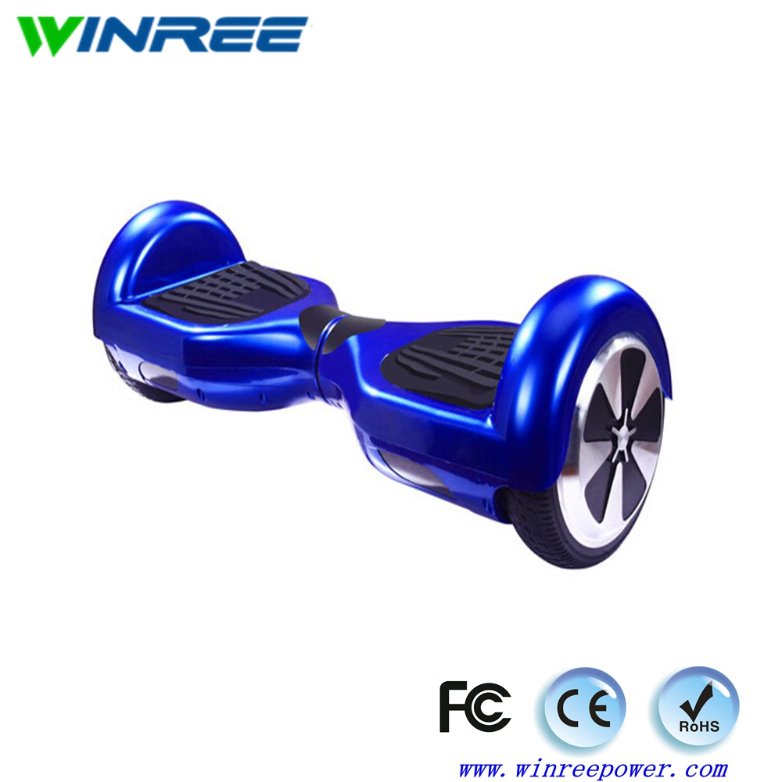

Packaging & Shipping
Shipping:
1. FedEx/DHL/UPS/TNT , Door-to-Door;
2. By Air or by Sea for batch goods, for FCL; Airport/ Port receiving;
3. Customers specifying freight forwarders or negotiable shipping methods!
4. Delivery Time: 3-7 days for samples;15-30 days for batch goods.

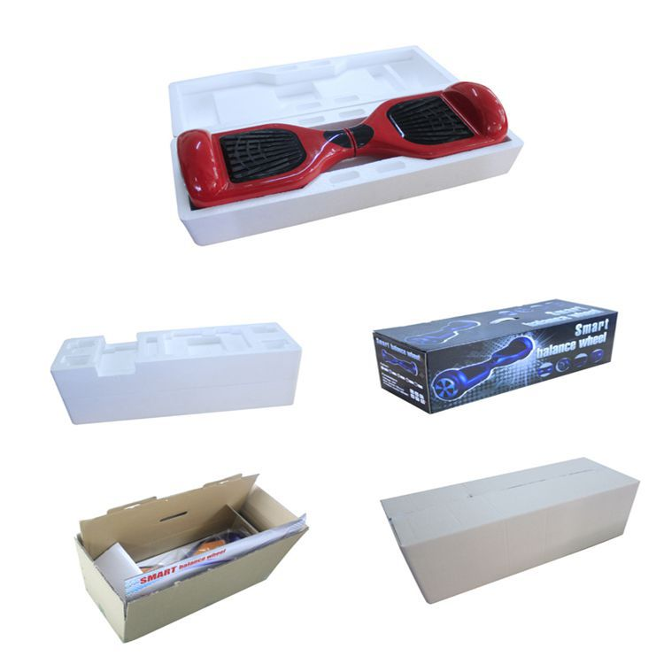
Our Services
Why choose us ?
4 years professional OEM manufacture experience.
Competition price from directly factory.
Golden after-sale services.
Company Information
2 wheels hover board electric scooter factory
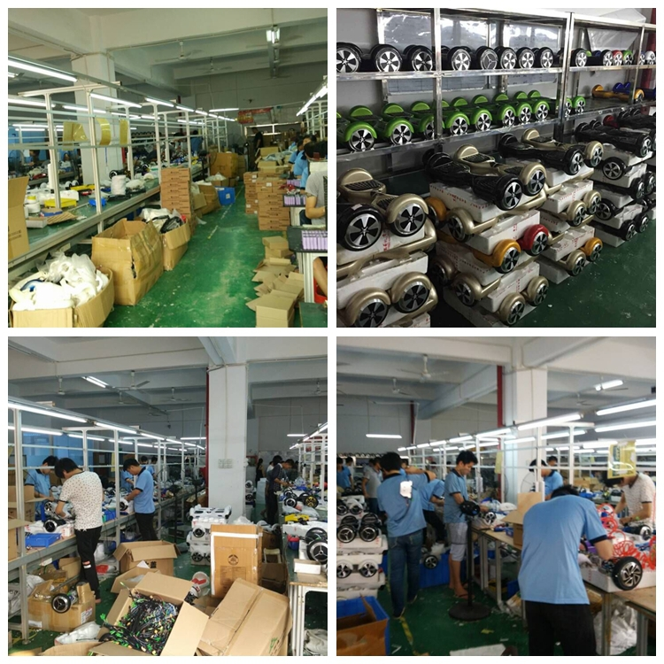

Product Uses
How to use it ?
You only need to slightly tilt your feet, will be able to control its direction, short-distance travel is very convenient.
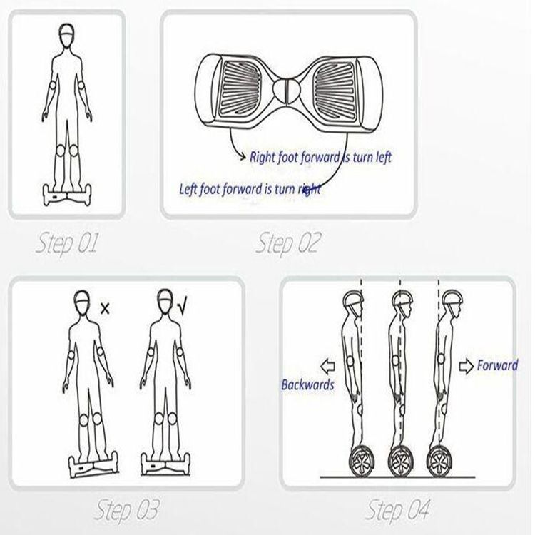
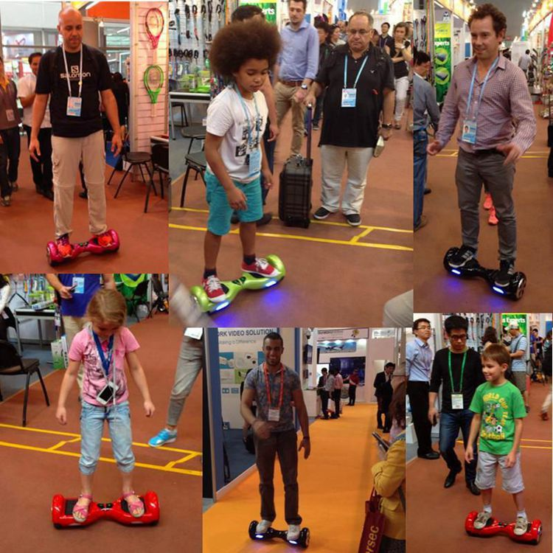
FAQ
1. Q: Can I get some samples?
A: Yes,sample order is available for quality check and market test.

2. Q: What’s the delivery time?
A: It usually takes about 25-40 working days for production based on specifications for your order and quantity.

3. Q: What's your payment terms?
A: We usually accept T/T or L/C at sight as the main payment terms,and other payment can also be negotiated.

4. Q: What's your warranty terms?
A: We offer different warranty time for different components,please contact us for details.

5. Q: Can I mix different models in one container?
A: Yes, different models can be mixed up in one full container.

6. Q: How does your factory do regarding the quality control?
A: Quality is priority. We always attach great importance to quality control from the very beginning to the end of the
production. Every product will be fully assembled and carefully tested before packing and shipping.

7. Q: Will you deliver the right products as I ordered? How can I trust you?
A: Yes, we will. The core of our company culture is honesty and loyalty. Our company has been audited and approved by
SGS, assessment report will could be sent to you by email.Also, we are alibaba’s Gold supplier. If you check with alibaba,
you will see that we have never got any complaint from our customers.

